Neural Sequence Labeling

Source: https://people.ischool.berkeley.edu/~dbamman/nlp20_slides/12_neural_sequence_labeling.pdf

RNN for POS
- Predict tag from context
- BiRNN: Concatenate final state of forward/backward RNN with word embedding to use as representation
- Character CNN: concatenate output with word embedding
- Limitation: long term dependency problem

Long Short Term Memory
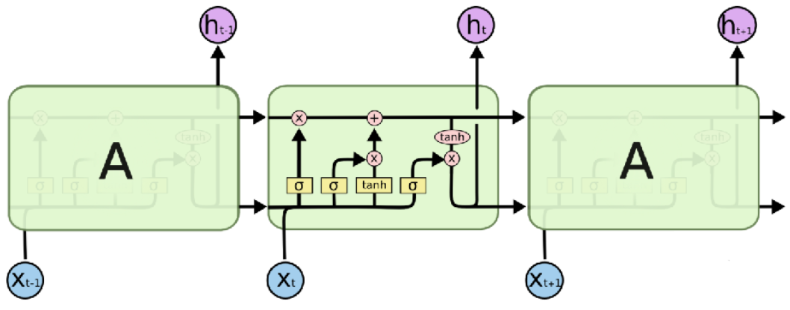
- Forget gate to decide what information to get rid of
- Input gate to update memory based selective current information
- Output gate to filter cell state
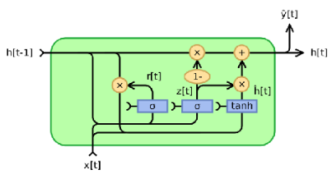
- Limitation: aware of up to 200 words of context

Gated Recurrent Unit
- Combine forget and input gates into single update gate
- Reduces # parameters to learn

